Jenkins Tutorial

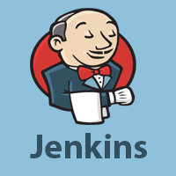

Jenkins Tutorial is designed for both beginners and professionals. Our Tutorial provides all the basic and advanced concepts of Jenkins, such as Jenkins installation, Jenkins Configuration, Jenkins Pipeline, etc.

Jenkins is an open source automation tool written in Java programming language that allows continuous integration.

Jenkins builds and tests our software projects, which continuously making it easier for developers to integrate changes to the project, and making it easier for users to obtain a fresh build.

What is Jenkins?